Distributed Trade Engine Documents

Requirements Specification Document

/ PRINT VERSION
The RSD is comprised of the following files:
- 00Contents.doc
- 00Forward.doc (includes Foreword, Executive Summary, and Introduction)
- 20UCModels.doc
- 21CntlSysState.doc
- 22DataReqs.doc
- 23EnterOrders.doc
- 24EnterQuotes.doc
- 25HandleTrades.doc
- 26LoginSecurity.doc
- 27MaintainModels.doc
- 28ProductMaintnce.doc
- 30Glossaries.doc
The documents are Word 95 (version 7.0a) files. Documents 21.. through 28.. are derived from Word 95 / SoDA documents.
Updating the Word Documents | 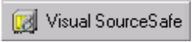 |  | Launch VSS version 4.0. Get the documents from the \Distributed Trading Engine\Project Documents directory.
The Table of Contents, Forward (includes Foreword, Executive Summary, and Introduction), and Use Case introduction (20UCModels) are Word documents and can be updated as any other Word file.
- Input changes or pull in materials from outside files.
- Verify header and footer text and manually increment the Revision number by 1.
- Verify paging. Major sections should begin on odd-numbered pages.
- Save the document.

 |   NOTE | If page numbering changes in any section due to revisions, initial page numbers must be reset in the first footer of each subsequent document.  Also remember to revise the Table of Contents accordingly.
Updating the Use Case Documents | In order to generate an updated use case document, updated information must be pulled from Clear Case and the updated model must be opened in Rational Rose.  Display your Clear Case directory in MS Explorer. The dteanalysis.mdl file is automatically available when you log on.
 | Check out any use case documents you wish to update. (You must check out any use case document you intend to generate; getting it will render it read only.)
 |  |  | Launch Rational Rose.  Open the dteanalysis.mdl database. The use case documents point to this database when they are generated, so the database must be up-to-date and open.
In Word, open the first use case document you wish to generate. Verify that the use case document is pointing to the correct Rose model.
From the SoDA Menu, select View Commands. The SoDA Command View window will display. Locate the OPEN command.
 | 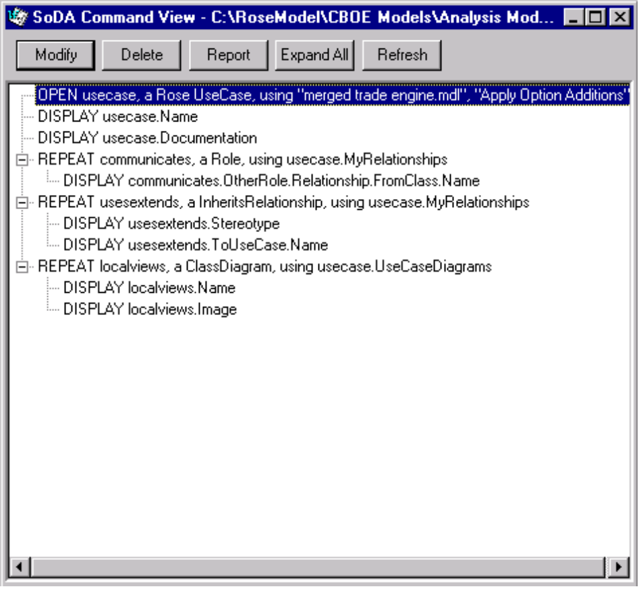
 | If the OPEN command is not pointing to the correct .mdl file, highlight the line and click Modify. The OPEN Command window will display.
 | 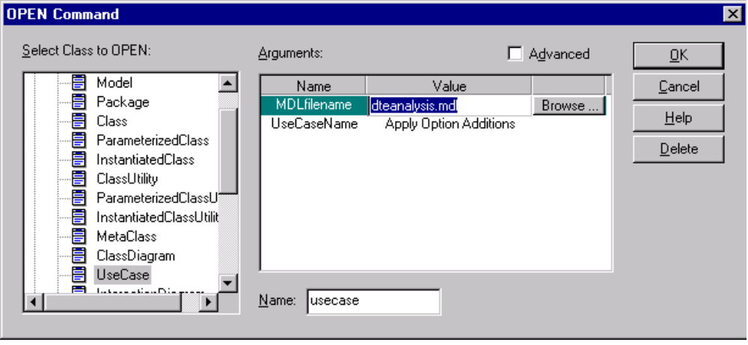

Highlight the .mdl filename value and click Browse.
Locate the correct .mdl in your Clear Case directory and click OK.
When you return to the Command View window, click Refresh. The program will refresh all of the document’s links. Click x to close the window.
Save the document.
From the SoDA Menu, select Generate Document. Leave all of the check boxes on the dialog box blank, then click OK. SoDA will generate the use case document and display it to the screen.
SoDA gives the generated document the same name as the original with Gen appended to the end (i.e., ApplyOptions.doc à ApplyOptionsGen.doc).
Updating the RSD Files | When you have completed regenerating the individual use case documents, update the RSD by inserting the new use cases into the appropriate file(s). Use cases are grouped by package and the files are named accordingly (or refer to the Table of Contents to determine which file contains the use case).
- Insert the updated use case in place of the old one or add new use cases as needed. Use cases are listed alphabetically within package.
- Verify header and footer text and manually increment the Revision number by 1.
- Verify paging. Each use case document should begin on an odd-numbered page. Add blank filler pages as needed.
- Save the document.

 | NOTE | If page numbering changes in any section due to revisions, initial page numbers must be reset in the first footer of each subsequent document.  Also remember to revise the Table of Contents accordingly.
 | The RSD is printed two-sided on the OCE or ODY printer.

8 INTRANET VERSION
 | Once the updated RSD is approved in print version, update the HTML files.
 |  | Launch VSS version 5.0.
Files maintained on the CBOE intranet are stored in Visual SourceSafe version 5.0. The database is located at \\intrapd\vss. Trade Engine files are stored in \intranet\xweb\tradeengine.
Get any of the following files that you need to update:
\tradeengine\trade002.htm (FrontPage)
\tradeengine\use case documents\00Forward.htm, etc. (Word)
Edit the documents in the applications in which they were created (Word, FrontPage).
- Rose Model use case diagrams will not display in html. They must be copied from the Word documents and saved individually as .JPG picture files, then embedded into place in the HTML file.
- Make text changes or copy revised text into the individual HTML documents.
- If updating an existing section, be sure not to overwrite the section title or the “Return to Top” bitmap. They are specified as a bookmarks linked to the TOC.
- If you are adding new sections, insert the text where applicable and format as needed to match existing text.
- Make any changes to the Table of Contents manually. Do not overwrite the TOC or all of the hyperlinks will be lost.
- Moving a New File to the intranet | When a new file is to be added to the intranet site, it must first be added to SourceSafe by selecting Add Files from the File Menu on the menubar. As the file is added to the SourceSafe database, it is also automatically copied to the intranet server.
Updating a File on the intranet | Once you have finished making the necessary changes, check the files back into SourceSafe. The updated versions will then be available for the next intranet access.

SBT Requirements Specification Document

/ PRINT VERSION
The SBT RSD is comprised of the following files:
- 00Forward.doc
- 02UCModels.doc*
- tradeengine/sbtcontents.htm
- tradeengine/sbtdocument/02UCMod.htm
- Updating the Document | Follow the Requirements Specification Document instructions beginning on page 1 for information on updating both the print and Intranet versions of this document.

SBT Committee Requirement Specifications Document

/ PRINT VERSION
The SBT Committee is responsible for updating and producing the print version of this document.

8 INTRANET VERSION
 |  | Launch VSS version 5.0.
Files maintained on the CBOE intranet are stored in Visual SourceSafe version 5.0. The database is located at \\intrapd\vss. Trade Engine files are stored in \intranet\xweb\tradeengine.
Get the following files:
\tradeengine\sbtdocument\sbtcomm.htm

Edit the document in the Word.
- Make text changes or copy revised text into the HTML document.
- If updating an existing section, be sure not to overwrite the section title or the “Return to Top” bitmap. They are specified as a bookmarks linked to the TOC.
- If you are adding new sections, insert the text where applicable and format as needed to match existing text.
- Make any changes to the Table of Contents manually. Do not overwrite the TOC or all of the hyperlinks will be lost.
- Moving a New File to the intranet | When a new file is to be added to the intranet site, it must first be added to SourceSafe by selecting Add Files from the File Menu on the menu bar. As the file is added to the SourceSafe database, it is also automatically copied to the intranet server.
Updating a File on the intranet | Once you have finished making the necessary changes, check the files back into SourceSafe. The updated versions will then be available for the next intranet access.

Proof of Concept Report

/ PRINT VERSION
The Proof of Concept Report is comprised of the following file:
- PoCReport_v06_95.doc

The document is a Word 95 (version 7.0a) file.
Updating the Word Documents |  | Launch VSS version 4.0. Get the documents from the \Distributed Trading Engine\Project Documents directory.
- Input changes or pull in materials from outside files.
- Verify header and footer text.
- Verify paging. Major sections should begin on odd-numbered pages.
- Save the document as the next sequential version number.

8 INTRANET VERSION
 | Once the updated Proof of Concept Report is approved in print version, update the HTML file.
 |  | Launch VSS version 5.
Files maintained on the CBOE intranet are stored in Visual SourceSafe version 5.0. The database is located at \\intrapd\vss. Trade Engine files are stored in \intranet\xweb\tradeengine.
Get the following file:
\tradeengine\ProofofConcept.htm (Word)
Edit the document as needed.
- Make the changes or copy revised text into the HTML document.
- Table formatting (alignment, shading) will not convert from .doc to HTML. Tables must be reformatted in HTML.
- If updating an existing section, be sure not to overwrite the section title or the “Return to Top” bitmap. They are specified as a bookmarks linked to the TOC.
- If you are adding new sections, insert the text where applicable and format as needed.
- Make any changes to the Table of Contents manually. Do not overwrite the TOC or all of the hyperlinks will be lost.
- Moving a New File to the intranet | When a new file is to be added to the intranet site, it must first be added to SourceSafe by selecting Add Files from the File Menu on the menu bar. As the file is added to the SourceSafe database, it is also automatically copied to the intranet server.
Updating a File on the intranet | Once you have finished making the necessary changes, check the file back into SourceSafe. The updated version will then be available for the next intranet access.

CBOE Architecture Documents
(Integration, Technology, and SBT Application)

/ PRINT VERSION
The Architecture documents are comprised of the following files:
- Integration_Arch_95.doc
- Tech_Arch_95_Pt1.doc (report)
- Tech_Arch_95_Pt2.doc (appendices)

The documents are Word 95 (version 7.0a) files. The SBT Application document was originally printed by the project team, so there is no print version cataloged in SourceSafe.
Updating the Word Documents |  | Launch VSS version 4.0. Get the documents from the \Distributed Trading Engine\Project Documents directory.
- Input changes or pull in materials from outside files.
- Verify header and footer text.
- Verify paging. Major sections should begin on odd-numbered pages.
- Save the documents.

8 INTRANET VERSION
 | Once the updated architecture documents are approved in print version, update the HTML files.
 |  | Launch VSS version 5.
Files maintained on the CBOE intranet are stored in Visual SourceSafe version 5.0. The database is located at \\intrapd\vss. Trade Engine files are stored in \intranet\xweb\tradeengine.
Get the following files:
\tradeengine\iadocument\iadoc.htm (Word)
\tradeengine\tadocument\tadoc.htm (Word)
\tradeengine\aadocument\aadoc.htm (Word)
Edit the documents as needed.
- Make the changes or copy revised text into the HTML documents.
- Table formatting (alignment, shading) will not convert from .doc to HTML. Tables must be reformatted in HTML.
- If updating an existing section, be sure not to overwrite the section title or the “Return to Top” bitmap. They are specified as a bookmarks linked to the TOC.
- If you are adding new sections, insert the text where applicable and format as needed.
- Make any changes to the Table of Contents manually. Do not overwrite the TOC or all of the hyperlinks will be lost.
- Moving a New File to the intranet | When a new file is to be added to the intranet site, it must first be added to SourceSafe by selecting Add Files from the File Menu on the menubar. As the file is added to the SourceSafe database, it is also automatically copied to the intranet server.
Updating a File on the intranet | Once you have finished making the necessary changes, check the files back into SourceSafe. The updated versions will then be available for the next intranet access.

